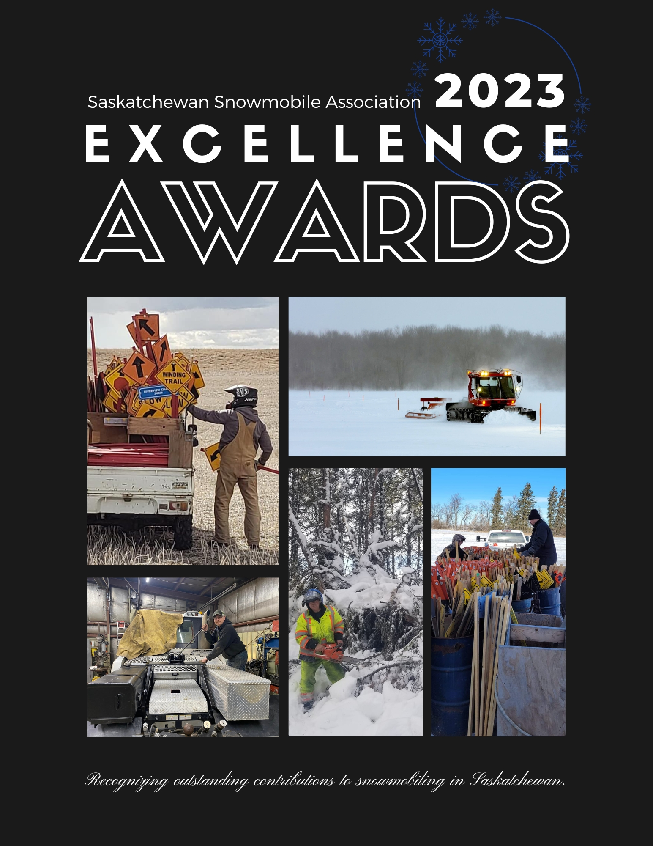
Saskatchewan Snowmobile Association
Awards of Excellence 2022-2023
The Saskatchewan Snowmobile Association Awards of Excellence formerly known as the Diamonds in the Snow Awards has been revised and will continue based on a club survey that was completed this past season. The nomination dates have been changed to stay within the snowmobile season with the nomination forms being available from December 1st, 2022 until March 15th, 2023. Nominees will be recognized, and awards distributed by the end of March.
There are seven (7) nomination categories available for nominators to provide submissions for. The four (4) categories for Volunteer Snowmobiler, Volunteer Groomer, Youth Snowmobiler and Volunteer Family will all be recognized with an award and with the remaining three (3) categories for Business, Snowmobile Dealer and Club of the Year will be judged and selected by the events committee.
At the end of the SSA award season is an opportunity for the office to submit nominations to the CCSO Awards of Excellence and that is where further judging from the four (4) categories of Volunteer Snowmobiler, Groomer, Youth and Family will occur from the committee as we are only able to submit one (1) nomination in each category. So please be mindful when submitting your nomination to make it really stand out and show the outstanding attributes your nominee has!
Board and Staff are included in the nomination process and can nominate others in all categories. Judges may not nominate in the categories including Business, Snowmobile Dealer or Club of the Year.
Nomination Categories
There are seven (7) categories of Diamonds in the Snow Awards. The categories and conditions of admissibility are as follows:
1. Snowmobile Dealership – Award of Excellence
This category is to reward one dealership on the basis of their involvement in the recreation of snowmobiling. The brand of snowmobile they sell and the number sold are not a consideration. A good dealer should have total involvement in the recreation and be a member of the Saskatchewan Snowmobile Association. Must be in operation between April 1st – March 1st of the current year.
2. Saskatchewan Snowmobile Club – Award of Excellence
This category is to recognize one club in the Province who has contributed to the exposure & promotion of snowmobiling thus contributing to the Recreation of Snowmobiling. The recipient of this award must be a club member of the Saskatchewan Snowmobile Association.
3. Snowmobile Family – Award of Excellence
This category is to recognize snowmobile families who have distinguished themselves in the areas of volunteerism, leadership, safety, promotion and community outreach. The recipients of this award must be members of a Saskatchewan Snowmobile Association Club.
4. Volunteer Snowmobiler – Award of Excellence
This category is to reward individuals who have provided volunteer services to their local club and has contributed to community activities, snowmobile safety and promotion of the recreation. The recipient of this award must be a member of a Saskatchewan Snowmobile Club.
5. Youth Snowmobiler - Award of Excellence
This category is to recognize young snowmobilers who have been active in snowmobiling activities, (specifically charitable) goodwill endeavors, fund raising and encouraging youth to go snowmobiling. The nominee must be under the age of 18 and his/her parents must be a member of their local snowmobile club.
6. Business Contribution to Snowmobiling - Award of Excellence
This category will recognize one outstanding business for its exceptional contribution, during the past year, to the promotion of snowmobiling. All business types involved or affecting snowmobiling may be nominated for this award. Must be in operation between April 1st – March 1st of the current year.
7. Groomer of the Year – Award of Excellence
This category is to recognize groomer operators for outstanding work grooming Saskatchewan snowmobile trails. A volunteer or paid groomer can be recognized in this category.
Rules and Regulations
Whoever won in a category last year cannot be nominated in this year’s awards in the same category however THEY CAN be nominated in other categories regardless of past wins.
All nomination ballots must be received no later than March 15, 2023. .
Best Option
Email: jenn@sasksnow.com with a copy to yourself for proof.
Option #2
Canada Post or by Courier:
Saskatchewan Snowmobile Association
Box 533
Regina Beach, SK S0G 4C0
All inquires may be directed to Jennifer Schneider,
(306) 729-3508 or by email: jenn@sasksnow.com

Saskatchewan Snowmobile Association Awards of Excellence Nominations
Please complete this nomination form and highlight or circle the appropriate award category in which you are nominating. Please answer the questions on the following nomination categories and feel free to add additional information.
AWARD CATEGORY
Highlight/underline or bold only one
- Snowmobile Dealer
- Snowmobile Club
- Snowmobile Family
- Volunteer Snowmobiler
- Youth Snowmobiler
- Business Contribution to Snowmobiling
- Groomer Operator of the Year
DUE MARCH 15, 2023
Nominee name: _________________________________________
Mailing Address: _________________________________________________
City/Province: _________________________________________________
Postal Code: _____________________________________
Telephone: ( ______ ) ______ - __________
Name of Nominator: ________________________________
Signature of Nominator: __________________________________
Date: ____/____/_____
1. Snowmobile Dealership
1) How many years has the snowmobile dealership been operating?
2) Explain what you feel is most important to this snowmobile dealership?
3) Describe the dealers involvement with the local snowmobile club(s) and/or community if no club?
4) What services/support does the dealer offer?
a. Snowmobile sales (new) Yes No
b. Snowmobile sales (used) Yes No
c. Snowmobile rental Yes No
d. Sale of accessories Yes No
e. Repair service Yes No
f. Repair service (weekend) Yes No
g. Promotion of snowmobiling events Yes No
h. Safety Instruction Yes No
i. Trail development Yes No
j. Other (specify):
5) Please tell us in 1-2 sentences why this dealer should be recognized as the Dealer of the Year.
6) What information or assistance does the dealer provide to new snowmobilers before they take to the trails?
7) Provide specific examples of how the dealer supports and promotes snowmobiling within their community?
8) Provide proof that the dealer is still recognized by one (or more) of the four snowmobile manufacturers and remains a business at the time of both the nomination and announcement of this award.
9) Please provide the physical street address of the dealership including town and postal code, web url and owner contact information.
2. Snowmobile Club
1) How many years has this snowmobile club been in operation?
2) How many club members are currently in the club? Has the membership increased over the past year? What does the club do to bring in new members?
3) How many kilometers of trail does the club maintain and have they developed or expanded the trail system in the past 12 years?
4) Describe how the club promotes safe and responsible riding for members and non-members.
5) What are the three most important events organized by this club in the current year? Please provide details on how these projects or events support and promote snowmobiling within the community. Provide details and specific examples in the last 12 months.
6) Does this club participate in the annual Snowmobile Association sponsored SSA Raffle?
7) Does this club sell or encourage members to purchase a local Club Membership, SSA Family/Individual and or Business Membership?
8) Does this club host charitable events?
9) What distinguishes this club from other clubs in the area? Does the club provide awareness or snowmobiling to new riders from other clubs or snowmobile organizations in the area?
10) Explain how this club has above all, distinguished itself in the following areas: management, safety, promotion and development, community outreach, and providing opportunities for snowmobilers to ride?
11) What were the highlights or accomplishments in the current season?

3. Snowmobile Family
1) Please identify each member and the number of years each has been involved with the sport.
2) Has the nominee purchased a Saskatchewan license plate for each machine owned?
3) What club does the family belong to and for how long? List their involvement in volunteer with the local club.
4) Please list any SSA Online training courses that your family or family members may have taken this past year?
5) What distinguishes this snowmobile family from others for this award?
6) Describe their volunteer activities with their local club under the headings of: Safety, Trail development/maintenance, Environment, Promotion, Fund Raising
7) Describe three snowmobile club activities in which they have organized and or participated in the past year.
8) What do they feel are the most important objectives of their snowmobile club and how do they initiate and implement these objectives?
9) What do they expect from their local snowmobile club?
10) Describe a snowmobile tour this family has experienced.
11) What were the highlights or accomplishments in the current season?

4. Volunteer Snowmobiler
1) How many years has the individual been actively involved in snowmobiling?
2) How does this individual get other involved in organized recreational snowmobiling?
3) What club are they a member of and for how long?
4) Has the individual completed any SSA Online Training courses such as the Trail Evaluator, the online grooming course, or Trail Signing?
5) Does this person register snowmobiles that they use with a current valid Saskatchewan license plate?
6) Describe three snowmobiling activities or events in which they have organized or participated in the past year.
7) Describe their snowmobile volunteer activities under the headings of leadership, safety, promotion of responsible riding, environment, community outreach and trail development.
8) Why should this individual be named to receive a volunteer snowmobiler excellence award?
9) In 1 or 2 sentences, summarize how this individual made snowmobiling better?
10) What were the highlights of accomplishments in the current season?

5. Youth Snowmobiler
1) How old is the individual?
2) What snowmobile organization/club is the individual associated with? Do they attend club meetings?
3) Has this nominee completed their safety course?
4) How long has the nominee been actively involved in snowmobiling? Does this nominee look after the maintenance of the snowmobile they ride?
5) Briefly describe some of the snowmobile projects/events that the nominee has been actively involved in over the past year.
6) Describe their volunteer activities with their local club or association under the headings of: Leadership, Safety, Promotion, Environment, Trail Development, Fund Raising, Youth involvement
7) How has this individual promoted the further development of snowmobiling as a family activity?
8) Why do you think that he/she should be named provincially as this year’s Youth Snowmobiler?
9) What were the highlights or accomplishments in the current season?

6. Business Contribution to Snowmobiling
1) How many years has this company been in business?
2) How many years has the company been actively involved with organized snowmobiling?
3) Was the nominee involved with the local club in financial or other ways?
4) Tell us what led the company to become involved in organized snowmobiling.
5) Describe how the company supports their snowmobile association/club or community.
6) What services does the company offer or support?
a) Sale of used snowmobiles Yes No
b) Snowmobile rental Yes No
c) Sale of accessories Yes No
d) Repair service Yes No
e) Repair service (weekend) Yes No
f) Snowmobile Programs Yes No
g) Safety Programs Yes No
h) Trail Development Yes No
i) Other(specify)
7) Please tell us why this company should be recognized as the Business of the Year related to organized snowmobiling.
8) What were the highlights or accomplishments in the current season?

7. Groomer Operator
1) How long has this individual been involved with the club or organization and what is their principal role?
2) What club are they are a member of?
3) Is this individual paid or a volunteer?
4) Has the operator taken the SSA Online Grooming or Trail Signing Courses?
5) Does this operator(s) attend Zone Meetings to address their clubs’ concerns regarding grooming?
6) How many hours has the groomer operated this year?
7) Describe three snowmobiling activities or events in which they have organized/or participated in the past year that deals specifically with grooming of snowmobile trails (could be fundraising, maintenance or the training and operation of the snow groomer or drag.)
8) Why should the nominee be named provincially as Groomer Operator of the Year?
9) In 1 or 2 sentences, summarize how this individual made snowmobiling better in their community?

